[](https://www.google.ca/url?sa=i&url=https://www.pinterest.com/alaalaamari/footballeur/&psig=AOvVaw11A76qLJAV-VLe6ruvI1I1&ust=1583019768677000&source=images&cd=vfe&ved=0CAIQjRxqFwoTCPi44bG29ecCFQAAAAAdAAAAABAU)[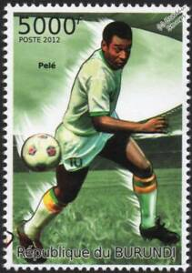](https://www.google.ca/url?sa=i&url=https://www.ebay.fr/itm/PELE-Brazil-Footballer-Legend-Football-Sport-Stamp-2012-Burundi-/132763557610&psig=AOvVaw1CvOhUf3w7lOy-ZC7rumju&ust=1583019114120000&source=images&cd=vfe&ved=0CAIQjRxqFwoTCNjW1P2z9ecCFQAAAAAdAAAAABAJ) [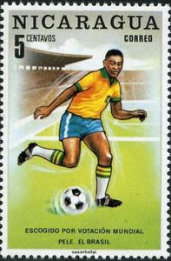](https://www.google.ca/url?sa=i&url=https://colnect.com/sv/stamps/stamp/462461-Pele_Brazil-FIFA_World_Cup_1970_-_Mexico-Nicaragua&psig=AOvVaw1CvOhUf3w7lOy-ZC7rumju&ust=1583019114120000&source=images&cd=vfe&ved=0CAIQjRxqFwoTCNjW1P2z9ecCFQAAAAAdAAAAABAP) [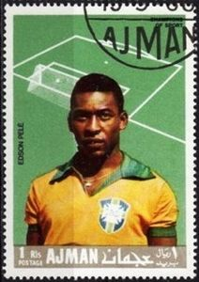](https://www.google.ca/url?sa=i&url=https://colnect.com/it/stamps/stamp/369336-Edson_Arantes_do_Nascimento_Pel%C3%A9_1940_FC_Santos-Calcio_migliori_giocatori_internazionali-Ajman&psig=AOvVaw1CvOhUf3w7lOy-ZC7rumju&ust=1583019114120000&source=images&cd=vfe&ved=0CAIQjRxqFwoTCNjW1P2z9ecCFQAAAAAdAAAAABAT) [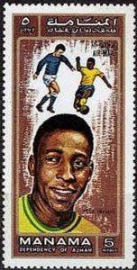](https://www.google.ca/url?sa=i&url=https://colnect.com/de/stamps/stamp/449819-Pele_1940_Brazil-Fu%C3%9Fballspieler-VAE_Emirat_Ajman_-_Manama&psig=AOvVaw1CvOhUf3w7lOy-ZC7rumju&ust=1583019114120000&source=images&cd=vfe&ved=0CAIQjRxqFwoTCNjW1P2z9ecCFQAAAAAdAAAAABAY) [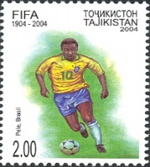](https://www.google.ca/url?sa=i&url=https://commons.wikimedia.org/wiki/File:Stamps_of_Tajikistan,_015-04.jpg&psig=AOvVaw1CvOhUf3w7lOy-ZC7rumju&ust=1583019114120000&source=images&cd=vfe&ved=0CAIQjRxqFwoTCNjW1P2z9ecCFQAAAAAdAAAAABAd) [](https://www.google.ca/url?sa=i&url=https://savemoney.es/asin/pel%C3%A9%20sports&psig=AOvVaw11A76qLJAV-VLe6ruvI1I1&ust=1583019768677000&source=images&cd=vfe&ved=0CAIQjRxqFwoTCPi44bG29ecCFQAAAAAdAAAAABAD)[](https://www.google.ca/url?sa=i&url=https://www.fnac.com/a9680513/Pele-naissance-d-une-legende-DVD-Leonardo-Lima-Carvalho-DVD-Zone-2&psig=AOvVaw11A76qLJAV-VLe6ruvI1I1&ust=1583019768677000&source=images&cd=vfe&ved=0CAIQjRxqFwoTCPi44bG29ecCFQAAAAAdAAAAABAJ) [](https://www.google.ca/url?sa=i&url=https://fr.shopping.rakuten.com/s/football%2Bpele&psig=AOvVaw11A76qLJAV-VLe6ruvI1I1&ust=1583019768677000&source=images&cd=vfe&ved=0CAIQjRxqFwoTCPi44bG29ecCFQAAAAAdAAAAABAO) [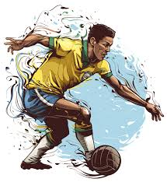](https://www.google.ca/url?sa=i&url=https://www.kissclipart.com/futbol-art-clipart-brazil-national-football-team-w-wae5y4/&psig=AOvVaw11A76qLJAV-VLe6ruvI1I1&ust=1583019768677000&source=images&cd=vfe&ved=0CAIQjRxqFwoTCPi44bG29ecCFQAAAAAdAAAAABAf)

|  |  |  |  |  |  |  |  |  |
| --- | --- | --- | --- | --- | --- | --- | --- | --- |
| **Mes objectifs** | **Points** | **Lundi** | **Mardi** | **Mercredi** | **Jeudi** | **Vendredi** | **Samedi** | **Dimanche** |
| Je réponds à la demande sans argumentations ou des gestes maniérés | **4** |  |  |  |  |  |  |  |
| Je fais mes demandes de manière respectueuse. **(J’évite la critique, plainte, reproches et insultes=Provocation)** | **4** |  |  |  |  |  |  |  |
| J’utilise des mots pour m’exprimer (**Parle au JE, utilise un ton calme et garde une distance physique)** | **4** |  |  |  |  |  |  |  |
| Je fais de mon mieux pour contrôler mon comportement**. (me retire lorsque je suis trop fâché)** | **4** |  |  |  |  |  |  |  |
| J’identifie, nomme et utilise des moyens pour gère mes émotions. | **4** |  |  |  |  |  |  |  |
| Total de la journée | **20** |  |  |  |  |  |  |  |